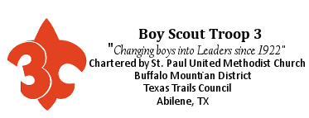

Hello Troop 3 and our Pack 212 friends!!!,
Troop 3 will be hosting our “End of Summer” camp out, family swim day, summer camp Court of Honor, and Webelos Crossover Ceremony weekend on Saturday, August 11th through Sunday, August 12th at Camp Tonkawa.

Contact Myron Schow, Troop 3 Committee Chair, (325-455-0047) or Mr. C. , Troop 3 Scoutmaster, (325-725-1461) if you have any questions.

Our weekend will start Saturday morning and we will come home Sunday around noon.

Troop 3
Troop 3 (including the new crossover Scouts) will meet at the Scout Hall about 8:00 AM, Saturday August 11th. WEAR your class “B” shirt to camp. Scouts need to pack for an overnight camp out, making sure to bring their swim suit and sun screen.

BRING YOUR FULL UNIFORM ON A HANGER, including T3 Cap and Neckerchief, a neckerchief slide, Scout shorts or pants (pants or shorts MUST have belt loops, NO basketball style elastic top pants or shorts worn with your Scout shirt), a BELT, and your merit badge sash and O.A. sash (if you have them). You will need them for the Court of Honor at dinner.

Once at Camp Tonkawa, the Troop will set up camp, then set up the tables and chairs in the Beaver Lodge for the evenings Court of Honor. Then they will have fun and eat lunch.

Schedule for Saturday:
8:00 AM – Troop 3 meets at St. Paul
12:30 PM – Pack 212 and T3 families start arriving
1:00 PM to 5:00 PM – Splash Day Family Swim
5:30 – 5:45 PM – Court of Honor begins

Pack 212 and our families and guests
If you are NOT a registered Scout or Scouter, you must turn in a signed copy of the “RELEASE AND INDEMNITY/HOLD HARMLESS AGREEMENT“ found at the end of this letter for EACH person in your group, this includes parents/guardians, siblings, or any other adults or children with your group. Registered Scouts and Scouters of Troop 3 or Pack 212 are already covered by their Troop/Pack agreement.

Pack 212 and our families and guests need to be there any time after 12:30 PM. The family swim will start at 1:00 PM, and end at 5:00 PM.

The Court of Honor and dinner will start about 5:30 – 5:45 ish in the afternoon on Saturday. This will be a sandwich, salad, and dessert, pot luck style dinner. Each family should bring enough of their favorite sandwiches (already made, or the fixings for build your own sandwiches), salads, and desserts to feed themselves and one or two more people. The Troop will provide the drinks, plates, flatware, ECT. We need a head count by Monday, August 8th, so we will have plenty for everyone. You may call Myron or Carl, or follow this link https://goo.gl/forms/FOrYjpcSjlbi3dkh2.

Any families wishing to camp out on Saturday night need to notify Troop 3 no later than Monday, August 8th with the number of people in your group, and the number and size of your tents. This is so we can figure out the space needed for all the tents. You will need to bring your own tents and camping / sleeping gear, along with food for your group for breakfast on Sunday morning. There may or may not be camp fires depending on weather conditions. Camp stoves may be the best option for cooking breakfast, or bring a “cold” breakfast (cereal, pop tarts, granola, trail mix, ect.)
INFORMATION FOR OUR FAMILIES AND GUESTS:
Please follow B.S.A. camping and youth protection policies & procedures

Camping with Troop 3 is to be guided first and foremost by the Scout Oath, Scout Law, the Outdoor Code and Leave No Trace principles. All youth protection policies are applicable to parents, guardians, grandparents, older (over 18) siblings and other adults who are with your group. There are NO EXCEPTIONS to this policy.

Youth Protection Policy:
Seeing that all Scouts have a fun and safe experience while camping and in all Scouting activities is the most important thing we do as leaders. The Boy Scouts of America has established practices to help ensure the protection of our children. After selecting the best possible leaders, further protections for children are structured into the program. The following policies have been adopted to provide additional security for youth in the program.
In addition, they serve to protect adult leadership from situations in which they are vulnerable to allegations of abuse.
Adherence to these policies not only enhances the protection of our membership, but also preserves the basic values of Scouting.

No One on One Contact:
One on one situations between adults and youth is not permitted, except between a parent/guardian and their child/ward. In situations that require personal conferences, the meeting is to be conducted in view of other adults and youth.

Respect of Privacy:
Adults need to respect the privacy of youth in situations such as changing into swimming suits or taking showers at camp and intrude only to the extent that health and safety requires. They also need to protect their own privacy in similar situations. Texas Trails Council has separate shower and latrine facilities for male and female youth, and male and female adults.

Accommodations:
When camping, no youth is permitted to sleep in the tent of an adult other than his own parent or guardian.
As a rule, when on a Troop camp out, all Scouts sleep with the Troop, in their Patrol Areas, the Troop adults sleep in their Patrol area, while parents and siblings sleep in the family area.

Appropriate Attire:
Proper clothing for activities is required. For example, skinny dipping is not appropriate as part of Scouting.
All clothing is to be modest (no see through tops or bottoms, no deeply cut tops, no short shorts or yoga pants/shorts), and may not have:
- tobacco or alcohol advertising,
- death heads, skulls, devils or demons, pentagrams, ect.
- objectionable words,
- objectionable symbols, or
- objectionable pictures
printed on it.

Swimwear per National Council Standards
For males: Brief suits (such as Speedos) and compression type trunks are inappropriate. If preferred, males may wear brief tank type suits, but they must be worn underneath boxer or gym style swim trunks.
For females: Bikini and two piece swimsuits are not suitable. One piece style swimsuits are suitable.

See pictures below for examples of inappropriate swimwear. If you have any questions please call us.

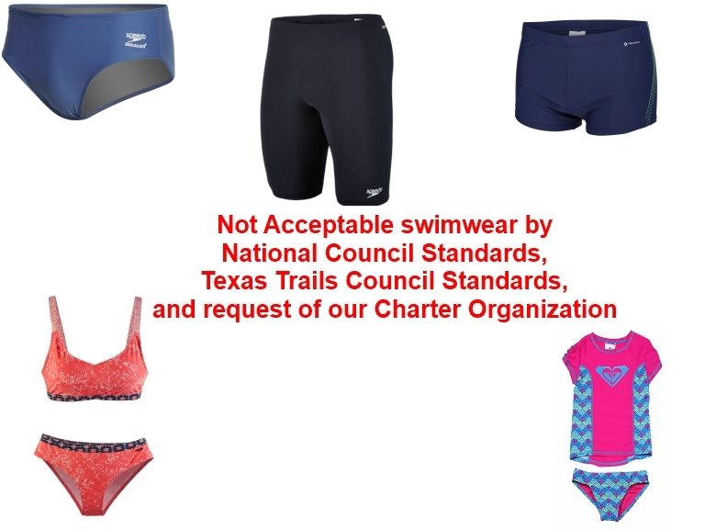

MAP TO CAMP TONKAWA
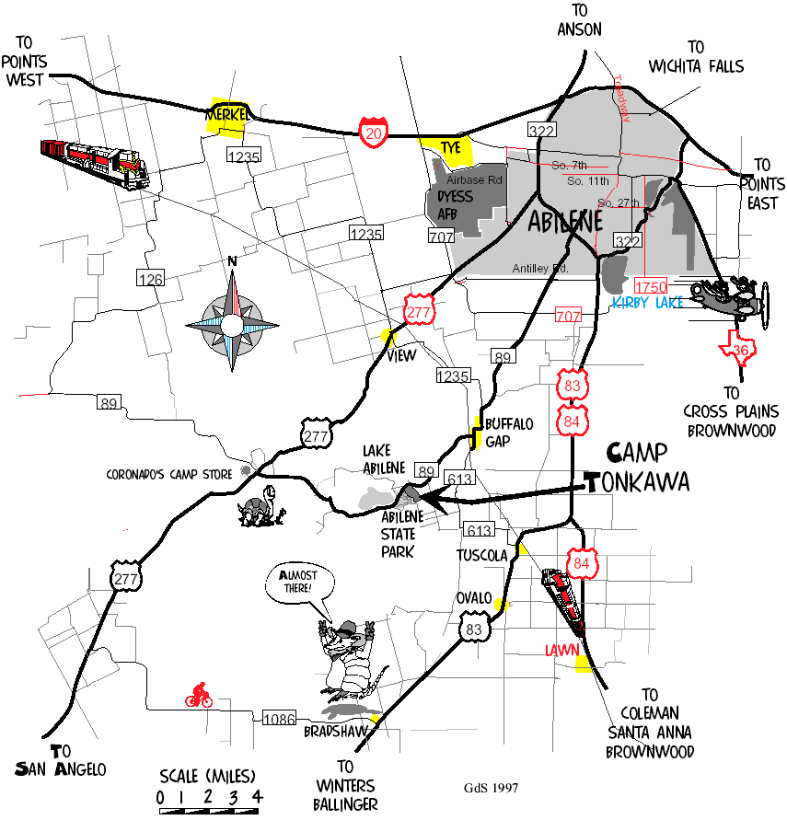

MAP OF CAMP TONKAWA

We will be at the Pool, Beaver Lodge and camping in Tonkawa and Navajo campsites.

Park in front of the Beaver Lodge, please. If you have mobility issues, call us.
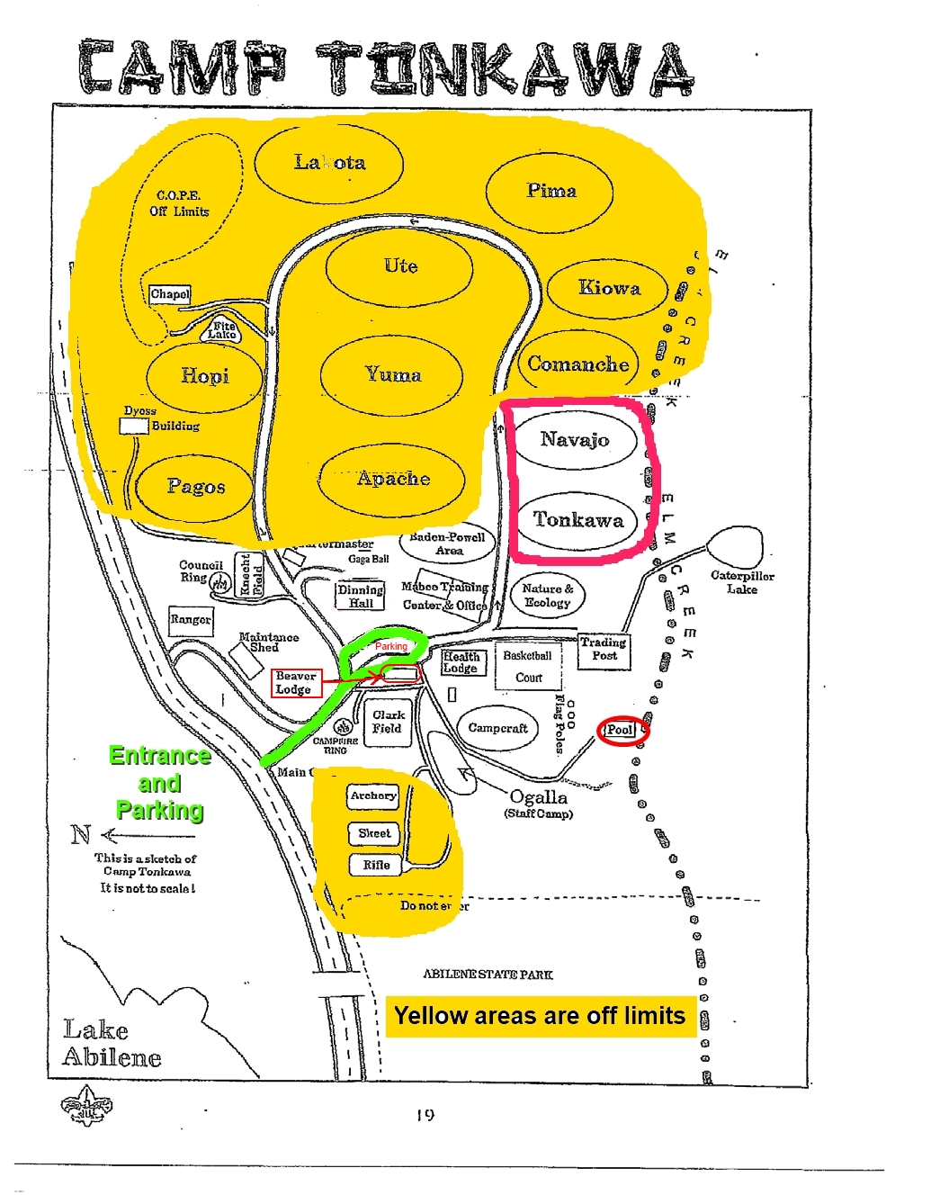
Texas Trails Council, BSA
3811 North 1st Street
Abilene, Texas 79603
325-677-2688

RELEASE AND INDEMNITY/HOLD HARMLESS AGREEMENT

I understand the use of facilities owned by Texas Trails Council, BSA involves a certain degree of risk that could result in injury or death. In consideration of the benefits to be derived and after carefully considering the risk involved and in view of the fact that the Boy Scouts of America is a not-for-profit organization:

RELEASE AND INDEMNIFICATION

I hereby release and waive any and all claims that I may have against the Boy Scouts of America Texas Trails Council, BSA and their employees, agents, representatives, or volunteers arising from use of their facilities. I AGREE TO FULLY INDEMNIFY AND HOLD HARMLESS BOY SCOUTS OF AMERICA, TEXAS TRAILS COUNCIL, BSA, AND THEIR EMPLOYEES, AGENTS, REPRESENTATIVES, OR VOLUNTEERS ARISING FROM USE OF THEIR FACILITIES. THIS INDEMNIFICATION EXPRESSLY INCLUDES ANY CLAIMS ARISING OUT OF THE HARMLESS BOY SCOUTS OF AMERICA, TEXAS TRAILS COUNCIL, BSA’S OWN NEGLIGENCE OR FAULT OR THAT OF THEIR EMPLOYEES, AGENTS, REPRESENTATIVES, OR VOLUNTEERS. I AGREE THAT THE INDEMNIFICATION INCLUDES THE AMOUNT OF THE CLAIMS, THE EXPENSES OF DEFENDING AGAINST THE CLAIMS, COURT COSTS, AND ATTORNEYS’ FEES.

_______________________________________________________
Participants Printed Name

__________________________________________ _________________________ _______________
Signature (if over 18 years of age) Telephone Number Date

If signatory is less than 18 years of age, this must also be signed by a parent or guardian

__________________________________________ _________________________ _______________
Parents or Guardians Signature Telephone Number Date

